

VCQI Results Interpretation  
Quick-Reference Guide

Draft Version 1.4

Revised October 2019



**Expanded   
Programme on Immunization**



This page is intentionally blank.

**Acknowledgements**

The Vaccination Coverage Quality Indicators software was developed for the World Health Organization by Biostat Global Consulting.

This document was developed for the World Health Organization by Biostat Global Consulting. It was written by Dale Rhoda, Mary Kay Trimner and   
Thomas Albani.

Introduction 1

RI_COVG: RI Survey – Measures Related to Coverage 2

RI_COVG_01: Crude coverage 2

RI_COVG_02: Valid coverage 2

RI_COVG_03: Fully vaccinated 3

RI_COVG_04: Not vaccinated 3

RI_COVG_05: Clusters with low crude coverage 3

RI_ACC: RI Survey – Measures Related to Access 4

RI_ACC_01: Crude DPT1 coverage 4

RI_CONT: RI Survey – Measures Related to Continuity of Services 5

RI_CONT_01: Dropout between two crude doses 5

RI_QUAL: RI Survey – Measures Related to Quality of Services 6

RI_QUAL_01: Card availability 6

RI_QUAL_02: Ever had a card 7

RI_QUAL_03: We recommend that you run RI_QUAL_04 instead of RI_QUAL_03. 7

RI_QUAL_04: Percent of doses administered before a specified age 7

RI_QUAL_05: Percent of sequential doses with an interval that is too brief 8

RI_QUAL_06: Percent of valid doses that were administered before the age of 12 months 8

A note regarding three indicators that summarize missed opportunities for simultaneous vaccination (MOVs) 9

RI_QUAL_07: Valid coverage if there had been no missed opportunities for simultaneous vaccination (MOV) 10

RI_QUAL_08: Percent of visits with missed opportunity for simultaneous vaccination (MOV) 10

RI_QUAL_09: Percent of children with missed opportunity for simultaneous vaccination (MOV) 11

RI_QUAL_12: Percent of sequential doses with an interval that is too long 12

RI_QUAL_13: We recommend that you run RI_QUAL_04 instead of RI_QUAL_13. 12

RI_CCC_01: Cumulative coverage curves (CCC) 13

RI_CIC_01: Cumulative interval curves (CIC) 14

TT_COVG: TT Survey – Measures Related to Maternal Tetanus Coverage 16

TT_COVG_01: Children born protected from neonatal tetanus 16

Post-SIA Survey – Measures Related to Coverage 17

SIA_COVG_01 Crude SIA coverage 17

SIA_COVG_02: Crude SIA coverage where SIA dose was the first dose 17

SIA_COVG_03: Lifetime measles doses, by birth cohort 17

SIA_COVG_04: Campaign coverage stratified by prior number of doses received 18

SIA_COVG_05: Clusters with alarmingly low campaign coverage 18

Post-SIA Survey – Measures Related to Quality of Services 20

SIA_QUAL_01: Received a campaign card 20

Interpretation of Other Statistics 21

2-sided 95% Confidence Interval (CI) 21

1-sided 95% Lower Confidence Bound (LCB) 21

1-sided 95% Upper Confidence Bound (UCB) 21

Design Effect (DEFF) 21

Intracluster Correlation Coefficient (ICC) 22

N (unweighted) 22

N (weighted) 22

## Introduction

This document is intended to guide interpretation of results in tables generated by the World Health Organization (WHO) software package named Vaccination Coverage Quality Indicators (VCQI)[1].

Other helpful VCQI resources include two documents named the VCQI User’s Guide and the Forms & Variable Lists (FVL) Structured for Compatibility with VCQI.

Broadly speaking, VCQI generates three types of tables:

1. Survey-weighted estimated proportions, where the denominator is the sum of weights for all respondents and the numerator is the sum of weights of the respondents with the characteristic of interest
2. Unweighted sample proportions, where the denominator is a count of a subset of respondents and the numerator is a count of a subset of the denominator
3. Several miscellaneous tables that do not fit the description of 1 or 2

This document is organized by VCQI indicator and it provides sample sentences that you may use to describe the meaning of entries in VCQI tables. It will often be helpful for you to also read VCQI table footnotes carefully, and mention material found there when it is relevant for interpretation.

Interpretation of unweighted proportions is straightforward. They are usually reported with two columns: one listing N and another listing %. The interpretation is generally of this form: “Of the N respondents who met the condition to be in the denominator, X% met the condition to be in the numerator of this indicator.” These proportions are reported without confidence intervals or any representation of sampling uncertainty. They are simple statements about what was observed in the survey sample.

Interpretation of VCQI’s survey-weighted proportions may be applied to the entire population of eligible respondents. They include a point estimate, 95% confidence interval and sample size and in some cases other summary statistics.

The document is organized by type of survey and by type of indicator, with Routine Immunization indicators listed first, then Maternal Tetanus surveys and finally Supplemental Immunization Activity (SIA) surveys. The final section of the document describes some additional statistics that are found in some VCQI tables, such as the design effect, intracluster correlation coefficient, and 1-sided confidence bounds.

Please send feedback on this document to Dale Rhoda at Biostat Global Consulting [Dale.Rhoda@biostatglobal.com](mailto:Dale.Rhoda@biostatglobal.com) or Carolina Danovaro at WHO [danovaroc@who.int](mailto:danovaroc@who.int).

You can find the latest version of this document at <http://www.biostatglobal.com/VCQI_resources.html>.

## RI_COVG: RI Survey – Measures Related to Coverage

### RI_COVG_01: Crude coverage

Weighted: Yes

Denominator: Sum of weights for all respondents

Numerator: Sum of weights for respondents who received the vaccine dose per card or recall   
(or register, if health centers were visited in this survey)

Missing/DNK: All respondents are in the denominator, even if their coverage responses from all sources are missing or “do not know” (DNK). In the numerator, respondents with missing data or DNK responses are considered to have not received the dose.

Interpretation: “X% of the population who were eligible for the survey are estimated to have received <*dose*>, as documented by <*source(s)*>.”

### RI_COVG_02: Valid coverage

Weighted: Yes

Denominator: Sum of weights for all respondents

Numerator: Sum of weights for respondents who received a valid dose per card or register

Missing/DNK: All respondents are in the denominator, even if their coverage responses from all sources are missing or “do not know” (DNK). In the numerator, respondents with missing data or DNK responses are considered to have not received the dose.

Interpretation: “X% of the population who were eligible for the survey are estimated to have a documented record of vaccinations (<*source(s)*>) and to have received a valid dose of <*dose*>.”

Note: The survey report should describe what is meant by a “valid dose”.

1. The child had reached the minimum age of eligibility for this dose.
2. If the schedule specifies a maximum age of eligibility, then the child was within the allowable age range when they received the dose.
3. If the dose is number 2 or 3 (or higher) in a sequence, then the minimum interval had passed since receiving the earlier dose, so the child was eligible to receive the next dose.

### RI_COVG_03: Fully vaccinated

Weighted: Yes

Denominator: Sum of weights for all respondents

Numerator: Sum of weights for respondents who received all <the doses in the list that makes up   
“fully vaccinated” >

Missing/DNK: All respondents are in the denominator, even if their coverage responses from all sources are missing or “do not know” (DNK). In the numerator, respondents with missing data or DNK responses are considered to have not received the dose.

Interpretation: “X% of the population who were eligible for the survey are estimated to be fully vaccinated, with <*either crude or valid doses>* having received <*list of doses to be fully vaccinated*>.”

### RI_COVG_04: Not vaccinated

Weighted: Yes

Denominator: Sum of weights for all respondents

Numerator: Sum of weights for respondents who received none of <the doses in the list that makes up “fully vaccinated”>

Missing/DNK: All respondents are in the denominator, even if their coverage responses from all sources are missing or “do not know” (DNK). In the numerator, respondents with missing data or DNK responses are considered to have not received the dose.

Interpretation: “X% of the population who were eligible for the survey are estimated to be un-vaccinated, having no evidence of received any <*crude or valid*> doses of <*list of doses to be fully vaccinated*> by the sources of information examined in this survey.”

### RI_COVG_05: Clusters with low crude coverage

Weighted: User-specifies, yes or no

Denominator: Count (or sum of weights) for all respondents in the cluster

Numerator: Count (or sum of weights) for respondents who received the dose

Missing/DNK: All respondents are in the denominator, even if their coverage responses from all sources are missing or “do not know” (DNK). In the numerator, respondents with missing data or DNK responses are considered to have not received the dose.

Interpretation: “Low coverage is defined here as being a cluster where fewer than <threshold> <percent or individuals> showed evidence of vaccination. The clusters highlighted in this list show evidence of low coverage for at least one of <list of doses considered>.”

## RI_ACC: RI Survey – Measures Related to Access

### RI_ACC_01: Crude DPT1 coverage

Weighted: Yes

Denominator: Sum of weights for all respondents

Numerator: Sum of weights for all respondents who received DPT1 / PENTA1

Missing/DNK: All respondents are in the denominator, even if their coverage responses from all sources are missing or “do not know” (DNK). In the numerator, respondents with missing data or DNK responses are considered to have not received the dose.

Note: The output for RI_ACC_01 is simply a copy of the output for RI_COVG_01 for the DPT1 (or PENTA1) dose. When it is calculated as RI_ACC_01, it may be given an interpretation that explicitly mentions access to vaccination services.

Interpretation: “X% of the population who were eligible for the survey are estimated to have access to vaccination services because they show evidence of having received <DPT1 / PENTA1>, as documented by <*source(s)*>.”

## 

## RI_CONT: RI Survey – Measures Related to Continuity of Services

### RI_CONT_01: Dropout between two crude doses

Weighted: No

Denominator: Number of respondents who received the first dose and were age-eligible to receive the second dose before the survey

Numerator: Number of respondents who received the first dose and who were eligible but did not receive the second dose

Missing/DNK: If data for the first dose is missing or DNK, the respondent does not appear in the denominator because only those with evidence of receiving that dose are counted there. If they have evidence of vaccination for the first dose, they are in the denominator and then if evidence for the second dose is missing or DNK then they will be counted as having dropped out (did not receive the second dose) in the numerator.

Description: It is common and straightforward to calculate weighted dropout results from the crude or valid coverage tables (i.e., from RI_COVG_01 and RI_COVG_02). For any two doses, (early and later) the commonly reported dropout proportion is simply   
( Cvg_early – Cvg_later ) / Cvg_early.

We could write code to generate a table of that quantity, but the weights themselves may not be especially helpful for this indicator. It may be more meaningful and easier to understand, if the software reports unweighted dropout proportions, where the denominator is a count of respondents who got the early dose and were eligible to have received the second dose rather than the sum of their weights. To be consistent with other unweighted VCQI measures, if the denominator does not include all respondents, this indicator estimates and reports an unweighted proportion.

Interpretation: “Among the <N> children who showed evidence of having received <earlier dose>, (per card or recall <or register>) and who were age-eligible to have received <later dose>, <dropout>% did not show evidence of receiving <later dose>.”

## 

## RI_QUAL: RI Survey – Measures Related to Quality of Services

### RI_QUAL_01: Card availability

Weighted: Yes

Denominator: Sum of weights for all respondents

Numerator: There may be up to nine numerators:

1. Sum of weights for respondents whose card (home-based record) was seen
2. Sum of weights for respondents who had card with at least one date
3. Sum of weights for respondents who had card with at least one date or tick
4. Sum of weights for respondents who had card with only clean dates  
   (where *clean* means the date fell between the child’s DOB and the date of the survey (or between the earliest possible vx date and the date of the survey) and dates for dose series were in chronological order)
5. Sum of weights for respondents whose register (facility-based record) was seen
6. Sum of weights for respondents who had register with at least one date
7. Sum of weights for respondents who had register with at least one date or tick
8. Sum of weights for respondents who had register with only clean dates
9. Sum of weights for respondents whose card or register document was seen

Missing/DNK: All respondents are in the denominator, even if the response to showing a card or register is missing or DNK. In the numerator, anyone with missing/DNK responses would be counted as having NOT shown a card or register.

Interpretation: To interpret columns labeled “RI Card Availability”: “X% of the population eligible for the survey are estimated to have a home-based record available for interviewers to view.”

To interpret the column labeled “RI Card with Dates”: “X% of the population eligible for the survey are estimated to have a home-based record with 1+ vaccination dates written on it.”

To interpret the column labeled “RI Card with Dates or Ticks”: “X% of the population eligible for the survey are estimated to have a home-based record with 1+ dates or tick marks written on it.”

To interpret the column labeled “RI Card with Only Clean Dates”: “X% of the population eligible for the survey are estimated to have a home-based record with only clean dates recorded on it (where *clean* means the date fell between the child’s DOB and the date of the survey (or between the earliest possible vx date and the date of the survey) and dates for dose series were in chronological order).”

To interpret columns labeled “RI Register Availability”: “X% of the population eligible for the survey are estimated to have a facility-based record (*register*) available for interviewers to view.”

To interpret the column labeled “RI Register with Dates”: “X% of the population eligible for the survey are estimated to have a facility-based record (*register*) with 1+ vaccination dates written on it.”

To interpret the column labeled “RI Register with Dates or Ticks”: “X% of the population eligible for the survey are estimated to have a facility-based record with 1+ vaccination dates or tick marks written on it.”

To interpret the column labeled “RI Register with Only Clean Dates”: “X% of the population eligible for the survey are estimated to have a facility-based record with only clean dates recorded on it (where *clean* means the date fell between the child’s DOB and the date of the survey (or between the earliest possible vx date and the date of the survey) and dates for dose series were in chronological order).”

To interpret the column labeled “RI Card or Register Availability”: “X% of the population eligible for the survey are estimated to have either a home-based record (card) or a facility-based record (*register*), or both, available for interviewers to view.”

### RI_QUAL_02: Ever had a card

Weighted: Yes

Denominator: Sum of weights for all respondents

Numerator: Sum of weights for respondents who say that they ever received a card for the child

Missing/DNK: All respondents are in the denominator, even if the response to having received a card is missing or DNK. In the numerator, anyone with missing/DNK responses would be counted as having NOT ever received a card.

Interpretation: “X% of the population who were eligible for the survey are estimated to have received at least one home-based record (vaccination card), even if they no longer have it.”

### RI_QUAL_03: We recommend that you run RI_QUAL_04 instead of RI_QUAL_03.

### RI_QUAL_04: Percent of doses administered before a specified age

Weighted: No

Denominator: Number of respondents who had date of birth (DOB) data and a dose date, by card or register

Numerator: Number of respondents whose <dose> was given before <threshold> age (in days)

Missing/DNK: If the DOB or dose date is missing/DNK then the respondent is excluded from this indicator calculation.

Description: Often used to identify % of children who received DPT1 or MCV1 too early.

Note: If the dates of vaccination on card and register disagree, and one shows that <dose> was given before <threshold> and the other shows it was given on or after <threshold>, this indicator gives the benefit of doubt by counting it as having been given on or after the <threshold>. That is to say that it is considered preferable for the child to have been at least <threshold> days old when they received the dose. If another assumption is appropriate, the age at vaccination per card and per register are both saved in the RI_QUAL_04 dataset and another outcome could be calculated.

Interpretation: “Of N respondents in the sample for whom age-at-vaccination could be calculated for <dose>, X% received it before the age of <threshold> days.”

### RI_QUAL_05: Percent of sequential doses with an interval that is too brief

Weighted: No

Denominator: Number of <dose2> (& <dose3>) doses administered where the date was known for that dose and for the preceding dose

Numerator: Number of times the later was administered before <threshold> days had passed   
from the date of the earlier dose

Missing/DNK: If the vaccination date for dose1 is missing, the dose1 to dose 2 interval cannot be calculated, so that interval is excluded from the calculation. If the date for dose 3 is missing, the dose2 to dose 3 interval cannot be calculated so that interval is excluded. If the date for dose2 is missing, neither interval can be calculated, so the respondent is excluded from the indicator.

Description: Often used to identify % of DPT2 & 3 doses administered before 28 days had passed. This indicator assumes that it is best to have the doses administered at least as far apart as <threshold> days. It differs from RI_COVG_12 in that regard, because _12 assumes it is best to have the doses administered after an interval that is shorter than <threshold> days.

Interpretation: “Of N intervals in the sample where the data include dates for both the earlier and later dose of <vaccine>, X% of the intervals were shorter than <threshold> days.”

### RI_QUAL_06: Percent of valid doses that were administered before the age of 12 months

Weighted: No

Denominator: Number of children who had valid MCV1

Numerator: Number of children whose valid MCV1 was received before the age of 12 months

Missing/DNK: If the DOB or dose date is missing/DNK then the respondent is excluded from this indicator calculation.

Description: Often used to quantify the % of valid MCV1 doses administered before age 12 months

Interpretation: “Of N respondents in the sample who received a valid dose of <dose>, X% were administered before the age of 1 year.”

### A note regarding three indicators that summarize missed opportunities for simultaneous vaccination (MOVs)

RI_QUAL_07 and _08 and _09 all summarize MOVs in the survey dataset.

When interpreting the MOV indicators it is very important to be clear whether the analysis was done with the CRUDE option (invalid doses count) or the VALID option (early doses are ignored).

Consider a country where DPT is scheduled to be given at 6, 10 and 14 weeks. Consider a child who received DPT at 5, 9 and 13 weeks and who received measles at 9 months of age. The child did not receive 3 valid doses of DPT…only the doses at 9 weeks and 13 weeks were valid…and they were valid for DPT1 and DPT2. The dose received at 5 weeks was an invalid dose, so the child did not receive a 3rd valid dose. So if the MOV analysis does not give credit for invalid doses (specify VALID option when running VCQI) then when the child returns for the measles vaccine at age 9 months, they are considered to be eligible for a 3rd valid dose of DPT. And if they do not receive it along with measles, it is counted as a missed opportunity.

If, instead, the user gives credit for invalid doses (specifies the CRUDE option), then the child is still counted as having two valid doses of DPT, but they are not considered eligible for a 3rd dose at the measles visit, and that visit is not considered to be a missed opportunity for DPT.

Specifying the VALID option will result in higher results for the MOV indicators. If the parameter is set to VALID then the child described above would be considered to have an MOV for DPT3 when they receive measles but not DPT at 9 months. If instead, the parameter is set to CRUDE then they would not.

It is my (Dale Rhoda) understanding that at this time (February 2017) WHO does not formally advise countries to give additional doses in a series if the child has received the full target number of doses, but some were invalid. (The practice may vary from country to country and even within countries.) So to summarize performance of the vaccination program as it is administered, it is probably appropriate to use the CRUDE option in the analysis. But biologically, children who receive a full complement of valid doses are probably more likely to develop immunity than those who receive some or all invalid doses. So it may be informative to do the MOV analysis twice…once with the parameter set to CRUDE and again with the parameter set to VALID, and to compare the output.

### RI_QUAL_07: Valid coverage if there had been no missed opportunities for simultaneous vaccination (MOV)

Weighted: Yes

Denominator: Sum of weights for all respondents

Numerator: Sum of weights for all respondents who had valid dose plus the sum of weights for those who did not have a valid dose, but did have an uncorrected MOV

Missing/DNK: All respondents are in the denominator, even if their coverage responses from all sources are missing or “do not know” (DNK). In the numerator, respondents with missing dates or DNK responses are considered to still not have received the dose, even if there were no MOVs.

Interpretation: “X% of the population who were eligible for the survey would have been estimated to have a documented record of vaccinations (<*source(s)*>) and to have received a valid dose of <*dose*> if there had been no missed opportunities for simultaneous vaccination.”

### RI_QUAL_08: Percent of visits with missed opportunity for simultaneous vaccination (MOV)

Weighted: No

Denominator: Number of vaccination dates where a respondent was eligible to receive 1+ vaccinations

Numerator: Number of vaccination dates where a respondent did not receive all vaccinations for   
which they were eligible

Missing/DNK: If a child is age-eligible for a dose on a documented vaccination visit date but are missing evidence of vaccination on that date and the caregiver says they did not receive the dose, or they DNK whether the child received the dose, then the child will be counted in the numerator as having experienced an MOV for that dose on that date.

Interpretation: To interpret columns labeled “Visits with MOV for <dose>”: “Respondents did not receive <dose> in X% of the N visits where they were eligible for it.”

To interpret the column labeled “Visits with MOV for any dose”: “Respondents did not receive all doses for which they were eligible in X% of the N visits where they were eligible for one or more doses.”

To interpret the column labeled “MOVs per Visit”: “On average, respondents were not given R doses for which they were eligible in each vaccination visit.”

If MOVs per visit is a number smaller than 1, it may be helpful to interpret thus:

“On average, there was a missed opportunity for simultaneous vaccination in one out of every 1/R visits in the survey dataset.” (i.e., If the average MOVs per visit is 0.2, we

might say “On average there was a missed opportunity for simultaneous vaccination in one out of every 5 visits represented in the survey dataset.”

### RI_QUAL_09: Percent of children with missed opportunity for simultaneous vaccination (MOV)

Weighted: No

Denominator: Number of children with date of birth data and date of vaccination data indicating   
that they had 1+ visits for vaccination on days when they were eligible to receive the dose in question

Numerator: Number of children who experienced 1+ missed opportunities to be vaccinated for   
the dose in question

Missing/DNK: Children missing date of birth or date of vaccination are excluded from the denominator. Children missing any evidence of vaccination or with DNK responses will be counted as having had an MOV in the numerator if they are known to have had a vaccination visit after they were age-eligible for the dose.

Description: This analysis identifies the number (and percent) of respondents who:

* + - 1. experienced an MOV (for each dose)
      2. experienced an uncorrected MOV (for each dose)  
         (meaning that they had not rec’d a valid dose as of the time of the survey)
      3. experienced a corrected MOV (for each dose)  
         (meaning that they rec’d a valid dose sometime after their MOV or MOVs and before the survey)

When considering the MOVs calculated across all doses, it identifies the number (and percent) of respondents who:

1. experienced 1+ MOVs for any doses,
2. for whom all MOVs were uncorrected,
3. for whom all MOVs were corrected,
4. for whom some but not all MOVs were corrected.

Interpretation: To interpret columns labeled “Had MOV for <dose> %”: “Among the N children in the survey dataset who received some vaccinations on days when they were age-eligible to receive <dose>, X% of them experienced 1+ occasions where they were eligible to receive <dose> but did not receive it.”

To interpret the column labeled “MOV uncorrected for <dose> %”: “Among the N children in the survey dataset who visited vaccination services on days when they were eligible to receive <dose>, X% of them experienced uncorrected missed opportunities for vaccination with <dose>, that is, there were 1+ occasions where they were eligible to receive <dose> but did not receive it, and as of the date of the survey they still had not received it.”

To interpret the column labeled “MOV corrected for <dose> %”: “Among the N children in the survey dataset who visited vaccination services on days when they were eligible to receive <dose>, X% of them experienced corrected missed opportunities for vaccination with <dose>, that is, there were 1+ occasions where they were eligible to receive <dose> but did not receive it, but they did receive it at a later date.”

To interpret column labeled “Had MOV for any dose (%)”: “Among the N children in the survey dataset who visited vaccination services on days when they were eligible to receive any dose, X% of them experienced 1+ occasions where they did not receive all doses for which they were eligible.”

To interpret column labeld “All MOVs were uncorrected (%)”: “Among the N children in the survey dataset who experienced 1+ MOVs for any doses, X% had all of their MOVs still uncorrected at the time of the survey.”

To interpret column labeled “All MOVs were corrected (%)”: “Among the N children in the survey dataset who experienced 1+ MOVs for any doses, X% had all of their MOVs corrected by the time of the survey.”

To interpret column labeled “Some (not all) MOVs were corrected (%)”: “Among the N children in the survey dataset who experienced 1+ MOVs for any doses, X% had some but not all of their MOVs corrected by the time of the survey.”

### RI_QUAL_12: Percent of sequential doses with an interval that is too long

Weighted: No

Denominator: Number of times the two doses were administered and there was a recorded date for each

Numerator: Number of times the later dose was administered after the interval (in days) in question

Missing/DNK: If either date is missing, the interval is excluded from the indicator calculation.

Description: Often used to identify % of DPT2&3 doses administered at intervals longer than 56 days. This indicator assumes that it is best to have the doses administered after an interval that is shorter than <threshold> days. It differs from RI_COVG_05 in that regard, because _05 assumes it is best to have the doses administered after an interval that is at least <threshold> days long.

Interpretation: “Of N intervals in the sample where the data include dates for both the earlier and later dose of <vaccine>, X% of the intervals were longer than <threshold> days.”

### RI_QUAL_13: We recommend that you run RI_QUAL_04 instead of RI_QUAL_13.

### RI_CCC_01: Cumulative coverage curves (CCC)

This figure shows an example of a cumulative coverage curve:

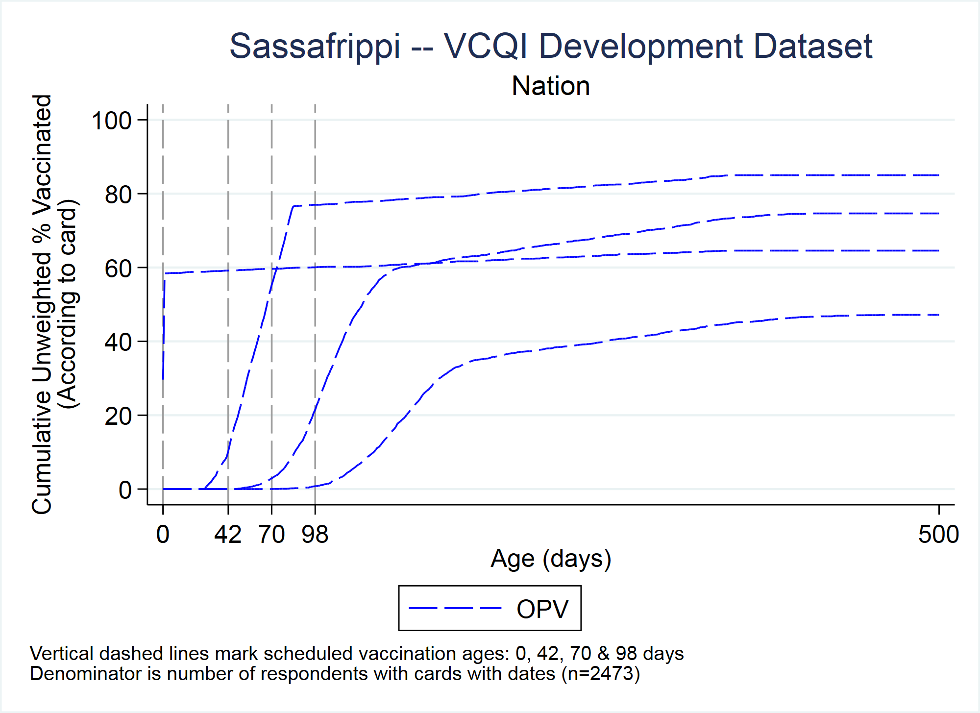

Weighted: Not currently weighted. We will implement a weighted version in the future.

Denominator: Number of respondents who had a card, valid date of birth, and at least one date of vaccination

Numerator: Number of respondents in the denominator who received the given dose by age X (in days)

Missing/DNK: Doses recorded with illegible dates or tick marks or whose dose date is missing altogether are not represented in these plots.

Interpretation: A point on a given cumulative coverage curve can be interpreted as: “For this sample, Y% of respondents who had a valid date of birth and at least one date on their vaccination card (or register date if using register data) were vaccinated for the given dose by the time the respondent was X days old.”

In a perfect world, these curves would be a stair-step function, where 0% of respondents received the dose until the scheduled age, at which time all 100% of respondents received the dose (vertical line straight up), then horizontal line extending to the right indicating no respondent received the dose after the minimum scheduled age.

On the plots, vertical lines mark scheduled vaccination ages, so the point at which the curve crosses its associated vertical schedule line should be at 0%. If there is white space under the curve *before* it crosses the vertical line, then that percentage of respondents received the given dose early. Similarly, white space *above* the curve after it crosses the vertical line but before the plateau represents respondents who were unprotected for that given time range.

### RI_CIC_01: Cumulative interval curves (CIC)

This figure shows an example of a cumulative interval curve that summarizes the distribution of observed intra-dose intervals (in days) between receiving OPV1 and OPV2.

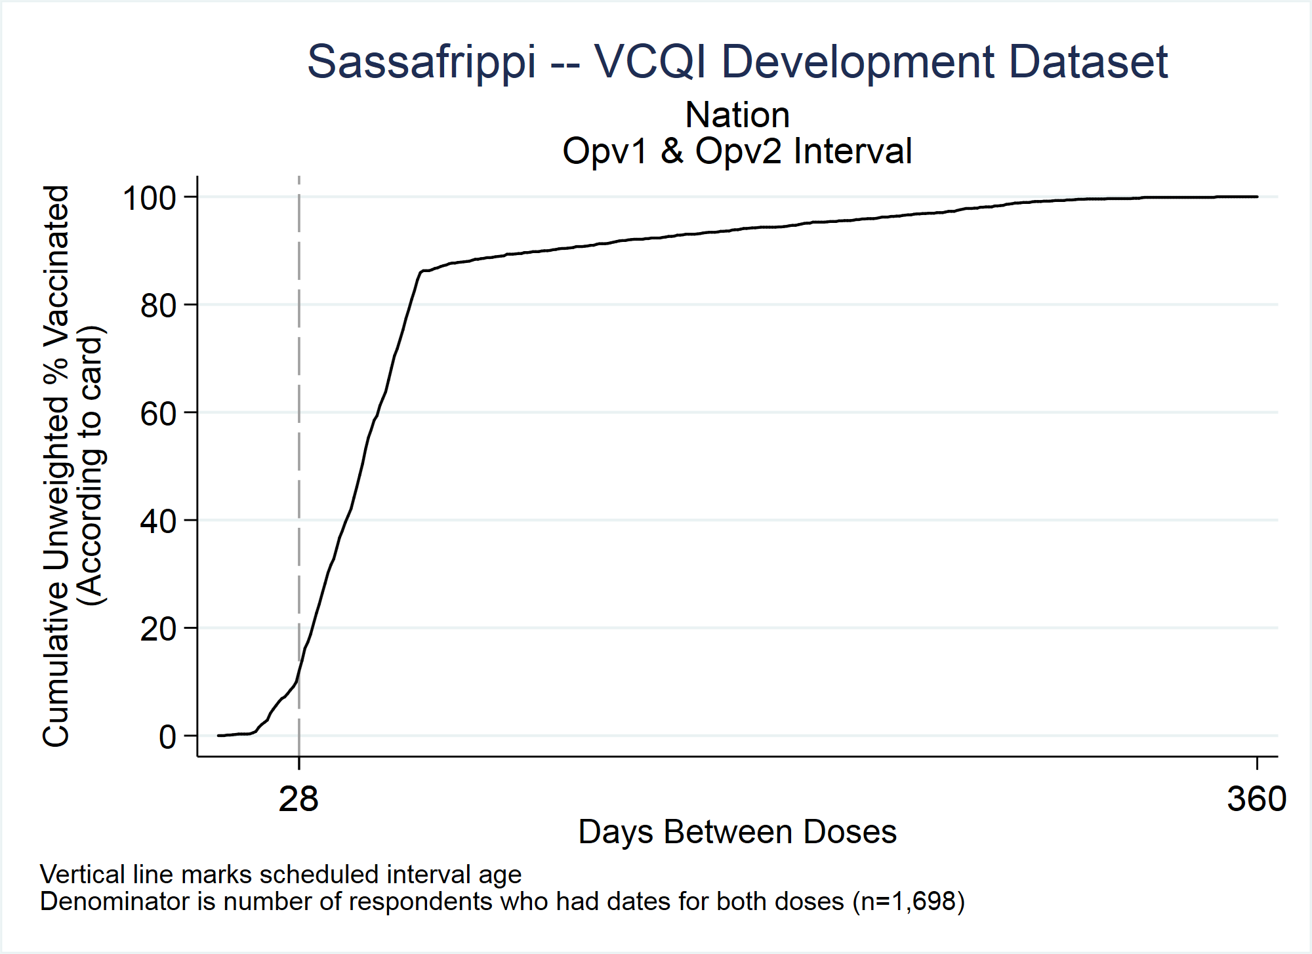

Weighted: Not currently weighted. We will implement a weighted version in the future.

Denominator: Number of respondents who had a date of vaccination for a given dose pair (e.g., OPV1 & OPV2)

Numerator: Number of respondents in the denominator whose difference (in age in days) between receiving the dose pair is less than or equal to a given threshold

Vaccines: Calculate for every two-dose antigen (interval between doses 1 and 2) and for every three-dose antigen (intervals between 1 and 2 and between 2 and 3)

Missing/DNK: Dose pairs recorded with illegible dates or tick marks or whose dose date is missing altogether are not represented in these plots.

Interpretation: A point on a given cumulative interval curve can be interpreted as: “For this sample, Y% of respondents who had evidence of receiving both doses on their vaccination card (or register dates if using register data) had an intra-dose interval no longer than X days.”

In a perfect world, these curves would be a stair-step function, where 0% of respondents received the latter dose until the scheduled interval, at which time all the respondents received the latter dose (vertical line straight up), then a horizontal line extending to the right indicating no respondent received the latter dose after the scheduled interval.

On the plots, vertical lines mark scheduled intervals, so the point at which the curve crosses it should be at 0%. If there is white space under the curve *before* it crosses the vertical line, then that percentage of respondents had too few days between doses (i.e., received the latter dose early). Similarly, white space *above* the curve after it crosses the vertical line but before the plateau represents respondents who experienced an interval longer than the scheduled number of interval days, and possibly were unprotected for that time period.

Notes: Two vertical lines may appear on the plot. The latter dose’s minimum interval in days, based on the schedule, is used to plot one vertical line. The difference between the dose pair’s minimum age in days, based on the schedule, is also calculated. If the difference is not equal to the minimum interval, then a second vertical line will appear on the plot. In this case, the interval between these two vertical lines represents a time period when a respondent could receive the latter dose, and it could be counted as early valid. Respondents having an interval period between a given dose pair that occurs before the first vertical line represents an early latter dose, whereas respondents having an interval period after the second vertical line represents a late latter dose.

For example, some countries schedule a first dose of measles rubella vaccine at age 9 months and a second dose at age 18 months. The scheduled intra-dose interval is 9 months, but the second dose would be considered valid anytime after a 28-day interval. So the plot for the MCV1 – MCV2 interval might include a vertical line at 28 days and a vertical line at 270 days (9 months). Anytime the second dose is received before 28 days have passed, the latter dose is early (invald). Anytime the second dose is received after 270 days have passed, the latter dose is late. (We use the term *late* here quite strictly. Some countries may not consider the dose to be officially *late* until one or two months have passed after the age when the dose is scheduled.)

## TT_COVG: TT Survey – Measures Related to Maternal Tetanus Coverage

### TT_COVG_01: Children born protected from neonatal tetanus

Weighted: Yes

Denominator: Sum of weights for all respondents

Numerator: Sum of weights for women whose children were protected at birth

Missing/DNK: Children are considered to not be born protected if they are born to women who are missing information about tetanus vaccination or who do not know how many doses they received or when the most recent dose was received

Interpretation: “X% of babies born in the 12 months preceding the survey are estimated to have been protected at birth from neonatal tetanus, according to evidence given from [maternal vaccination card and/or maternal recall of their vaccination history and/or health center records of maternal vaccinations].”

## 

## Post-SIA Survey – Measures Related to Coverage

### SIA_COVG_01 Crude SIA coverage

Weighted: Yes

Denominator: Sum of weights for all respondents

Numerator: Sum of weights for respondents who received the vaccine dose per   
[card, history, or finger mark]

Missing/DNK: All respondents are in the denominator, even if their coverage responses from all sources are missing or “do not know” (DNK). In the numerator, respondents with missing data or DNK responses are considered to have not received the dose.

Interpretation: “X% of eligible children who were living here during the campaign are estimated to have been vaccinated against [measles] during the recent campaign per information obtained [by card, by caregiver history, by finger mark].”

### SIA_COVG_02: Crude SIA coverage where SIA dose was the first dose

Weighted: Yes

Denominator: Sum of weights for all respondents

Numerator: Sum of weights for respondents who received the SIA dose and had never received a dose before

Missing/DNK: If the coverage response is missing or DNK or if the respondent doesn’t know whether they received a dose before, then this dose is not considered to be the first dose.

Interpretation: “X% of eligible children who were living here during the campaign received their first-ever dose of [measles] vaccine in the recent campaign.”

### SIA_COVG_03: Lifetime measles doses, by birth cohort

Weighted: Yes

Description: Each SIA will be targeted at a population of children who span several years of age. Each year of age is a one-year “birth cohort”. In this measure, we report how each cohort is divided across three categories: those for whom we do not find evidence (by card or history or fingermark or registry) that they ever received a dose of the campaign vaccine, those for whom we find evidence of a single lifetime dose of that vaccine, and those for whom we find evidence of 2+ doses. The three categories will sum to 100% for each cohort. (Do not know is not evidence and is treated as a zero.)

Denominator: Sum of weights for all respondents

Numerator: There are three numerators:

1. Sum of weights for respondents who report never having received a dose of the campaign vaccine
2. Sum of weights for respondents who show evidence of one lifetime dose of the campaign vaccine
3. Sum of weights for respondents who show evidence of 2+ lifetime doses of the campaign vaccine

Missing/DNK: If the number of lifetime doses is missing or DNK, the respondent is characterized as having never received a dose of the campaign vaccine.

Interpretation: “X% of children in the age cohort who had completed Y years gave verbal or documented indication of having received [0, 1, or 2+] lifetime doses of   
[the campaign vaccine].”

### SIA_COVG_04: Campaign coverage stratified by prior number of doses received

Weighted: Yes

Description: This indicator shows the campaign coverage stratified by the prior number of doses received.

Denominator: Sum of weights for all respondents

Numerator: There are up to ten numerators, each of the below for those vaccinated during campaign and not vaccinated during campaign

1. Sum of weights for all respondents who received the campaign dose and had received 0 doses prior to campaign
2. Sum of weights for all respondents who received the campaign dose and had received 1 dose prior to campaign
3. Sum of weights for all respondents who received the campaign dose and had received 2+ doses prior to campaign
4. Sum of weights for all respondents who received the campaign dose and did not know if they had received a dose prior to campaign
5. Sum of weights for all respondents who received the campaign dose and had received at least one dose prior to campaign, but not sure how many

Interpretation: “X% of children were vaccinated during SIA.”

“X% of children who received 0 doses prior to campaign were vaccinated during SIA.”

“X% of children who received 1 dose prior to campaign were vaccinated during SIA.”

“X% of children who received 2+ doses prior to campaign were vaccinated during SIA”

“X% of children who do not know if dose received prior to campaign were vaccinated during SIA.”

“X% of children who received a dose prior to campaign, but unsure how many were vaccinated during SIA.”

### SIA_COVG_05: Clusters with alarmingly low campaign coverage

Weighted: User-specifies, yes or no

Denominator: Count (or sum of weights) for all respondents in the cluster

Numerator: Count (or sum of weights) for respondents who received the dose

Missing/DNK: All respondents are in the denominator, even if their coverage responses from all sources are missing or “do not know” (DNK). In the numerator, respondents with missing data or DNK responses are considered to have not received the dose.

Interpretation: “Low coverage is defined here as being a cluster where fewer than <threshold> <percent or individuals> showed evidence of vaccination. The clusters highlighted in this list show evidence of low coverage.”

## 

## Post-SIA Survey – Measures Related to Quality of Services

### SIA_QUAL_01: Received a campaign card

Weighted: No

Denominator: Number of respondents who were vaccinated in the campaign

Numerator: There are three numerators:

Number of vaccinated respondents whose card was seen by survey data collectors

Number of vaccinated respondents who reported having a card, but it was not seen

Number of vaccinated respondents who either showed a card or reported receiving one

Missing/DNK: If the vaccination response is missing or DNK, the respondent is excluded from the denominator. If they were vaccinated, but the response regarding the card is missing or DNK then they are considered to have not received a campaign card.

Interpretation: “Among the N children who were vaccinated in the campaign, X% demonstrated that they received a card.”

“Among the N children who were vaccinated in the campaign, X% reported having received a campaign card, but did not show it.”

“Among the N children who were vaccinated in the campaign, X% either demonstrated that they received, or reported having received a campaign card.”

## Interpretation of Other Statistics

The earlier portions of this document describe how to interpret the main outcomes of the survey – the estimated coverage proportions. This final section describes how to interpret some of the additional statistics that are reported with weighted indicators.

### 2-sided 95% Confidence Interval (CI)

Reports often state that the survey team is “95% confident” that the true coverage in the target population falls within the 95% confidence interval obtained from the sample. If the survey is believed to be free of important biases, this is an acceptable way to present results to policymakers. Strictly speaking, the confidence interval means: “If this survey were repeated, without bias, many, many times using the same target population, the same design, the same sampling frame and protocol, the same questions, and the same analysis, and if a confidence interval were calculated using the same technique for each repetition of the survey, then 95% of the intervals would indeed contain the true population coverage number”.

We cannot know whether the sample selected for a given survey is one of the 95% of samples that generates an interval containing the true population parameter, or whether it is one of the 5% of samples for which the entire confidence interval lies above or below the true population parameter. However, for practical purposes (and in the absence of important biases), it is acceptable say we are 95% confident that the true unknown population coverage figure falls within the estimated 95% CI from the survey sample.

Note that the interval that VCQI labels the 95% CI is a 2-sided interval and we consider there to be a 2.5% chance that the true probability coverage falls below the entire interval and a 2.5% chance that it falls above the entire interval.

### 1-sided 95% Lower Confidence Bound (LCB)

Informally, we say that in the absence of bias we are 95% confident that the true population coverage parameter falls above the LCB. The formal interpretation is similar to that described above for the 2-sided CI; when we say we are 95% confident, we mean that if the survey were repeated many times, the true parameter would fall above the LCB for 95% of those repeated surveys.

### 1-sided 95% Upper Confidence Bound (UCB)

Informally we say that in the absence of bias, we are 95% confident that the true population coverage parameter falls below the UCB. Formally, the interpretation involves many repeated surveys in a manner like that of the LCB and 95% CI described above.

### Design Effect (DEFF)

When outcomes are estimated using data from a complex sample, they often have a variance (degree of uncertainty due to sampling) that is larger than would have been achieved with a simple random sample using the same sample size. The ratio of the achieved variance to the variance that would have been observed with a simple random sample is known as the design effect. If you divide the actual sample size by the design effect, you calculate what is called the effective sample size. This is the number of respondents you would have to enroll in a simple random sample to achieve the same variance or the same confidence interval width that you achieved with the complex sample. The design effect is useful for planning subsequent surveys.

### Intracluster Correlation Coefficient (ICC)

The ICC is another quantity that is useful for planning subsequent surveys. It measures the correlation of the outcome within clusters in the sample. It is a number between -1 and 1. It often falls between 0 and 1. An ICC of 0 means that the likelihood of having the outcome (i.e., of being vaccinated) does not vary by which cluster a respondent occupies. In other words, an ICC of 0 means that the outcome does not vary spatially. At the other extreme, an ICC of 1 means that the outcome is perfectly correlated with which cluster a respondent occupies. Higher values of ICC lead to higher values of design effect.

### N (unweighted)

N is the number of respondents in the denominator of the measure.

### N (weighted)

N is the sum of the weights of the respondents in the denominator of the measure.

1. Pronounced “Vicki”